1. Alampalli, Shravani
2. Team D – Phoenix
3. **Client**: Dr. Michael Oudshoorn
4. **Project** - Slack/Hipchat collaboration tool
5. **Role** – Issues Management.
6. **ITERATION PLAN:**

I have been assigned the role of issues management for this project. I am responsible for tracking all the issues in the project and ensures that they are resolved on time. I think 10-12% of work is completed by me, by having a client meeting, research on collaboration tools and gathered some crucial requirements to get started with the project. Until now project progress is on track and going well. We got an idea about few requirements on which our team divided the tasks. Even requires more to get an idea about requirements.

**What accomplishments you made last week.**

We had few client meetings regarding requirements and also regarding issues for the ideas which we have. After meet with client we decided the domain in “Project Management Collaboration Tools”. I arranged two team meetings in order to get a detailed idea about requirements after meeting the client. In team meeting we came across the requirements document. And divided the tasks in another team meeting according to everyone’s strengths. I came through the pros and cons of the existing system and to decide what would be the advantage from the existing system which took time nearly 13- 14 hours. Not only that from requirements doc I worked on task assigning which took even more time than the research on the existing time. Not only that I prepared a presentation slides in mid-semester presentation. I worked for 37 – 38hours in these week regarding above mentioned topics.

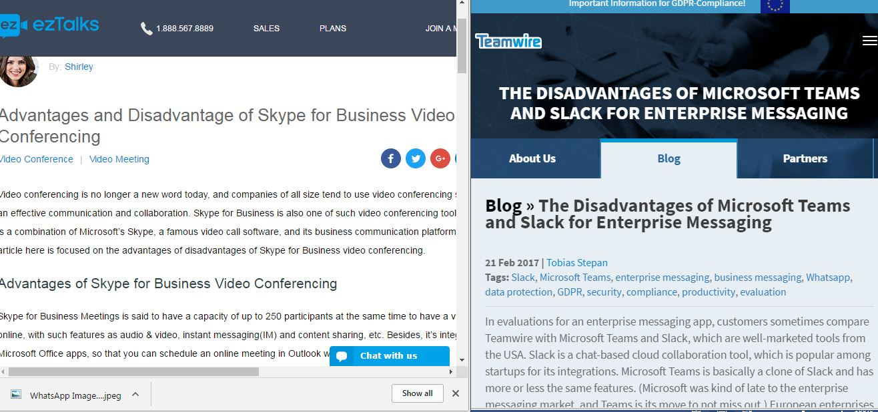

**Tasks to complete this week:**

1. Some more client meetings and get to know more about the requirements.
2. Team meetings in order to decide requirement documents and also use case and test cases for each requirement.
3. Doing the one of requirement document with its use case too.
4. Make sure to push the documentation to Github repository.

**Any unresolved issues or blockers that keep you from making progress.**

No unresolved issues or blockers that effect my progress in these week.

1. **What is the riskiest component under development?**

Deciding a domain is the riskiest component and gathering requirements according to the domain is even toughest task for me.

1. **What active efforts are most critical for client acceptance or GDP completion?**

Understanding the requirements of client and working on it to produce a required collaboration tool is very critical which is a final product. Satisfying client based on his requirements is also a critical thing.